6.2 Systems of Inequalities in Two Variables

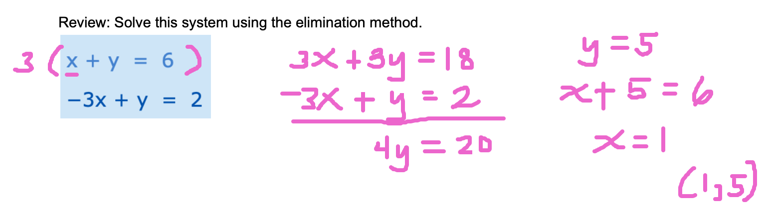

Introduction to Inequalities in Two Variables
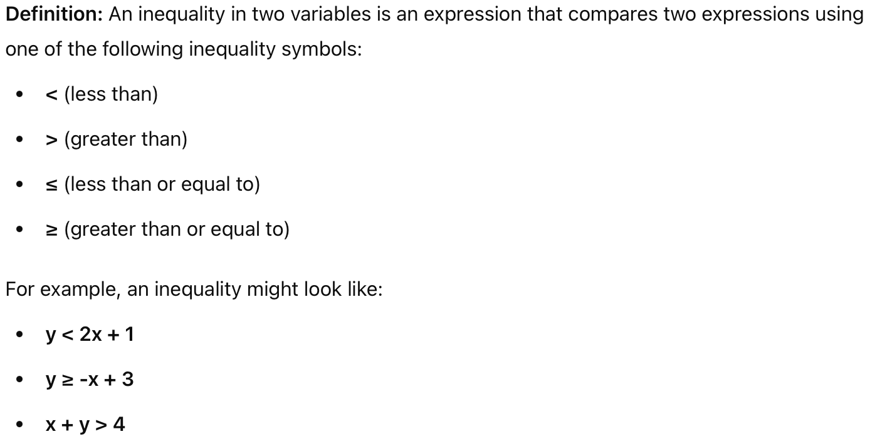

A linear inequality in two variables can be written as ax + by ≤ c, where a, b, and c are constants with a and b not equal to zero. (The symbol ≤ can be replaced by ≥, <, or >). If an ordered pair (x, y) makes the inequality a true statement, then (x, y) is a solution. The set of all solutions is called the solution set. The graph of an inequality includes all points (x, y) in the solution set.

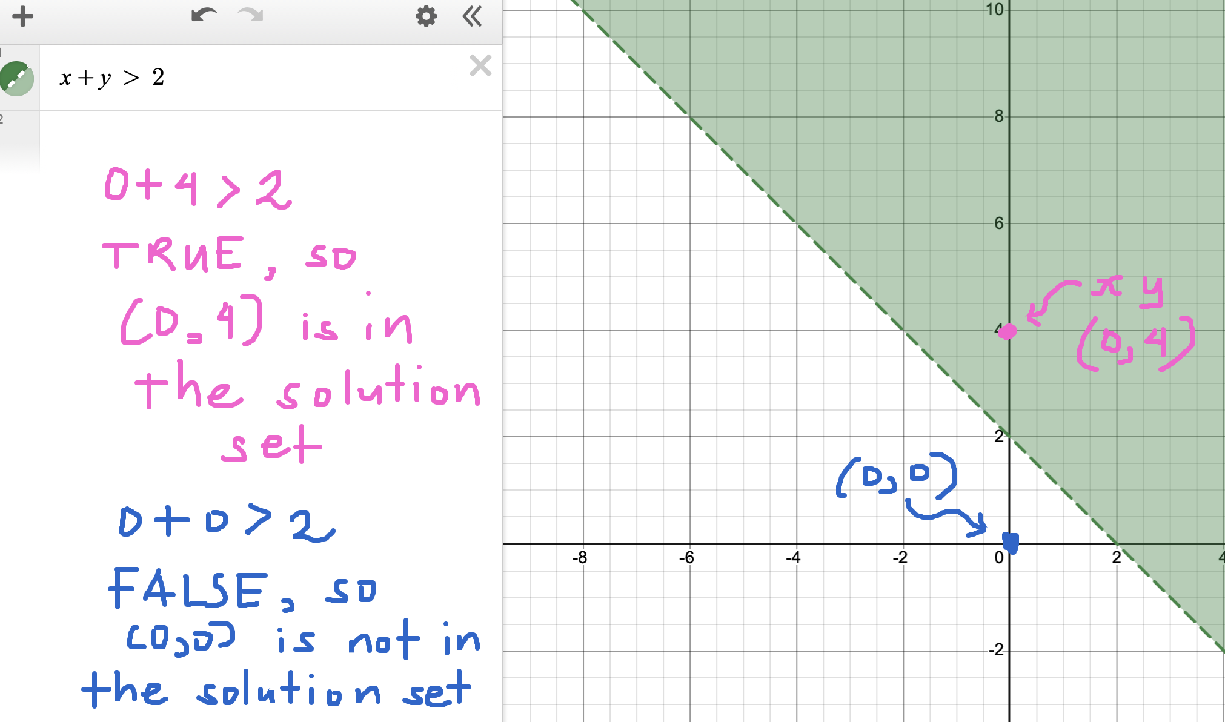

The graph of a linear inequality is a (shaded) half−plane, which may include the boundary. To determine which half−plane to shade, select a test point that is not on the boundary. If the test point satisfies the given inequality, then shade the half−plane containing the test point. Otherwise, shade the other half−plane.
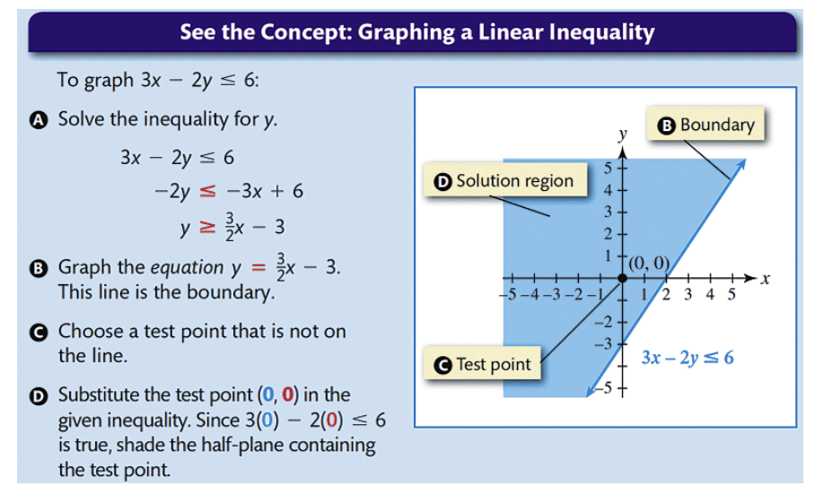
3(0) - 2(0) ≤ 6
0 ≤ 6 TRUE, so the point (0,0) [our test point] is in the solution set or the shaded region.

Example. Graphing an Inequality in Two Variables

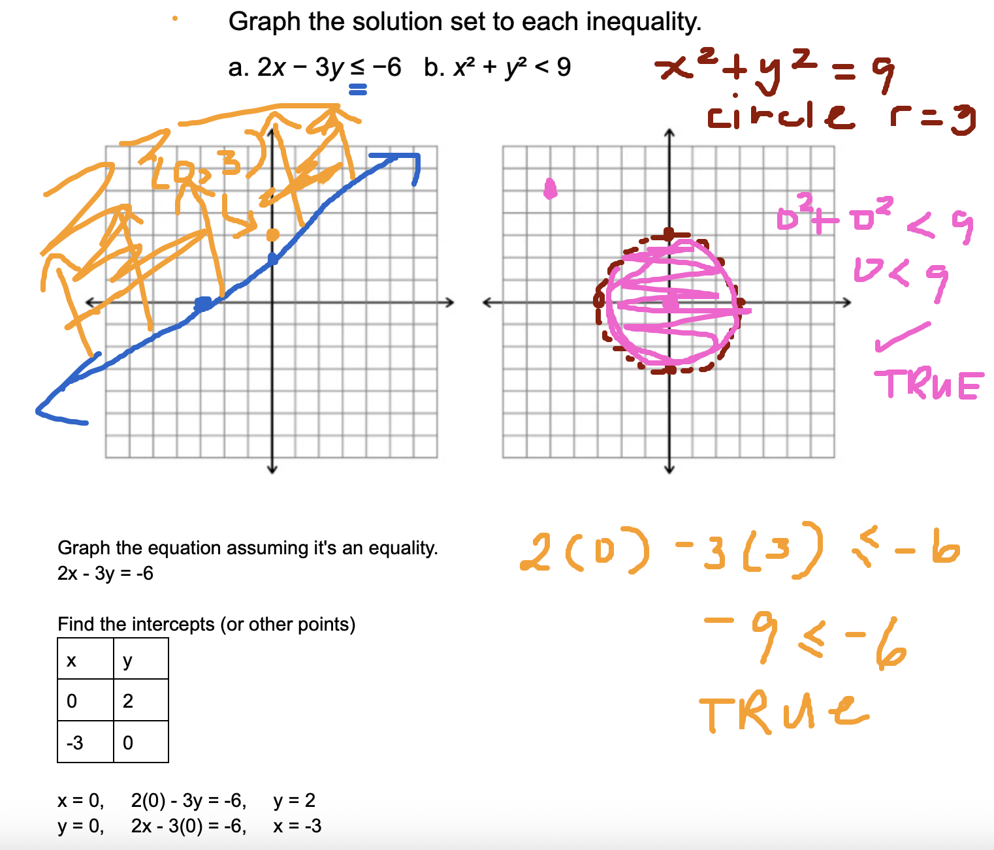

System of Inequalities in Two Variables

A system of inequalities involves two or more inequalities that share common variables. The solution to the system is the region where the shaded areas of all the inequalities overlap.

Example. Solving a System of Inequalities in Two Variables Graphically
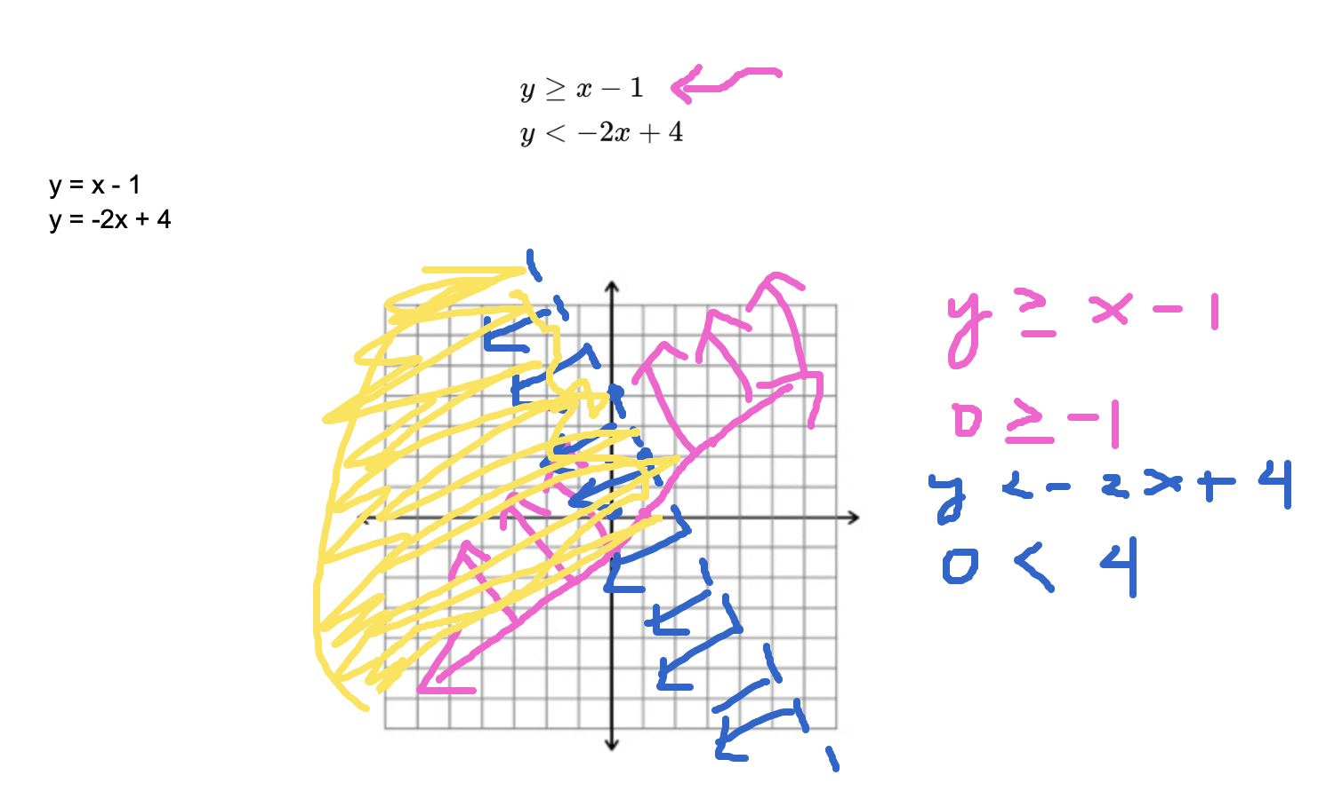

Practice Problems

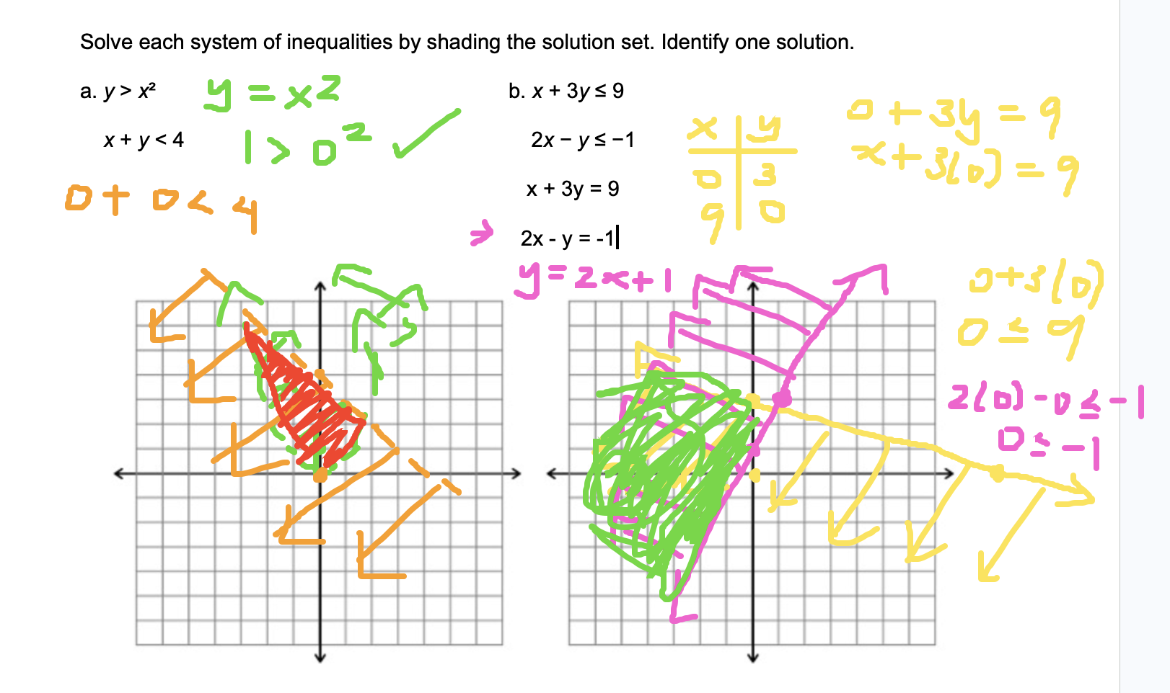

Word Problems
In word problems, inequalities are often indicated by phrases such as "at most," "at least," "no more than," "greater than," "less than," or "within a limit." These suggest constraints or boundaries on the variable, meaning the solution must satisfy certain conditions rather than being a specific value. For example, "You can spend at most $50" implies an inequality where the amount spent is less than or equal to 50, often leading to a solution region rather than a single point.

- Your baseball team has a goal to collect at least 160 blankets for a shelter. Team members brought 42 blankets on Monday and 65 blankets on Wednesday. Write and solve an inequality to find out how many blankets the team must donate on Friday to make or exceed their goal?

Total number of blankets should be at least 160

Inequality:
42 + 65 + x ≥ 160

Solve:
107 + x ≥ 160
x ≥ 53
They need to collect at least 53 blankets to make or exceed their goal.

- You have an allowance of $15.00 per week. You are in a bowling league that costs $6.50 each week, and you save at least $5.00 each week. Write and solve an inequality to show how much you have left to spend each week.
- A trailer can carry a maximum weight of 160 pounds and a maximum volume of 15 cubic feet. A microwave oven weighs 30 pounds and has 2 cubic feet of volume, while a printer weighs 20 pounds and has 3 cubic feet of space.
- Mary needs to purchase supplies of answer sheets and pencils for a standardized test to be given to the juniors at her high school. The number of the answer sheets needed is at least 5 more than the number of pencils. The pencils cost $2 and the answer sheets cost $1. Mary’s budget for these supplies allows for a maximum cost of $400.
- Omar needs to eat at least 800 calories before going to his team practice. All he wants is hamburgers and cookies, and he doesn’t want to spend more than $5. At the hamburger restaurant near his college, each hamburger has 240 calories and costs $1.40. Each cookie has 160 calories and costs $0.50.

1 hamburger has 240 calories, 1 hamburger costs $1.40
1 cookie has 160 calories, 1 cookie costs $0.50
at least 800 calories
less than 5 dollars.

x = # of hamburgers
y = # of cookies

Inequality involving calories
240x + 160y ≥ 800

Inequality involving money or dollars
1.40x +0.50y < 5

